Q1)
Ans :- <!DOCTYPE html>
<html lang="en">
<head>
<meta charset="UTF-8">
<meta name="viewport" content="width=device-width, initial-scale=1.0">
<title>Simple webpage</title>
</head>
<body>
<p>This text will be<b>bolded.</b></p>

<p><i>This text will be italic.</i></p>

<p><mark>This text will be highlighted.</mark></p>

<p>This is normal text <sup>This will be superscripted</sup>This is again normal text.</p>

<p>This is normal text <sub>This will be subscripted.</sub></p>

<p>Normal text <small>small text.</small></p>
<p> <del>This text will be deleted.</del></p>
</body>
</html>

Output:-

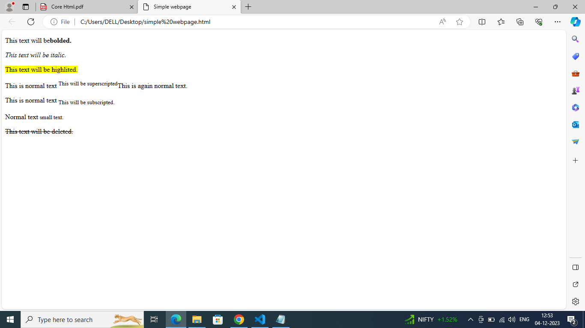

Q2)

Ans:-

<!DOCTYPE html>
<html lang="en">
<head>
<meta charset="UTF-8">
<meta name="viewport" content="width=device-width, initial-scale=1.0">
<title>Simple webpage</title>
</head>
<body>
<h1> Navigate Me:</h1>

Take me to <a href="https://pwskills.com" target="_blank"> PW Skills</a> to buy a new course.

Take me to <a href="https://developer.mozilla.org" target="_blank">MDN docs</a> to know more about Web Development.

Take me to <a href="https://lab.pwskills.com" target="_blank">PW Skills Lab</a> to practice live coding.

</body>
</html>

OUTPUT :-
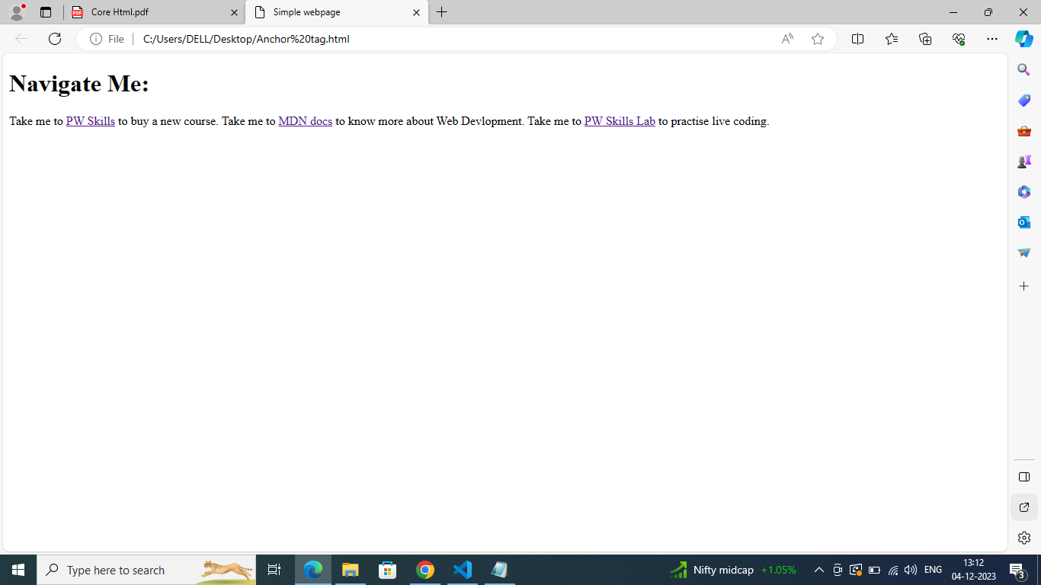

Q3)

Ans :-

<!DOCTYPE html>
<html lang="en">
<head>
<meta charset="UTF-8">
<meta name="viewport" content="width=device-width, initial-scale=1.0">
<title>Web Design</title>
</head>
<body>
<div>
<a href="https://www.w3schools.com/html/home.html">Home</a>
<a href="https://www.thecodehelp.in/webDevlopment.html">Web Development</a>
<a href="https://webdesigner.withgoogle.com/webdesignwebdesign">Web Design</a>
</div>

<div>
<h1>Web Design.</h1>
<p Web design refers to the process of designing the visual appearance and

layout of websites. It involves creating a visual concept, planning the

layout of web pages, selecting color schemes, and choosing typography

and images.

<br />

Web designers use various tools and technologies to create visually

appealing and user-friendly websites. These tools include graphic design

software such as Adobe Photoshop, Adobe Illustrator, Sketch, and Figma.

They also use programming languages like HTML, CSS, and JavaScript to

bring their designs to life on the web.></p>
</div>
</body>
</html>

<!DOCTYPE html>
<html lang="en">
<head>
<a href="https://www.w3schools.com/html/home.html">Home</a>
<a href="https://www.thecodehelp.in/webDevlopment.html">Web Development</a>
<a href="https://webdesigner.withgoogle.com/webdesignwebdesign">Web Design</a>

</head>
<body>
<div>

</div>

<div>
<h1>Web Development.</h1>

<p> Web development refers to the process of creating websites and web applications. This
involves a combination of different technologies and programming languages, such as HTML,
CSS, and JavaScript, to create web

pages and make them interactive.

<br />

Web development can be divided into two main categories: front-end development and
back-end development. Front-end development deals with the visual aspects of a website or
application, including the design, layout, and user interface. This involves working with
HTML, CSS, and JavaScript to create web pages that can be viewed in a browser.</p>
</div>
</body>
</html>

<!DOCTYPE html>
<html lang="en">
<head>
<meta charset="UTF-8">
<meta name="viewport" content="width=device-width, initial-scale=1.0">
<title>Web Design</title>
</head>
<body>
<div>
<a href="https://www.w3schools.com/html/home.html">Home</a>
<a href="https://www.thecodehelp.in/webDevlopment.html">Web Development</a>
<a href="https://webdesigner.withgoogle.com/webdesignwebdesign">Web Design</a>
</div>

<div>
<h1>Web Design.</h1>

<p> Web design refers to the process of designing the visual appearance and

layout of websites. It involves creating a visual concept, planning the

layout of web pages, selecting color schemes, and choosing typography

and images.

<br />

Web designers use various tools and technologies to create visually

appealing and user-friendly websites. These tools include graphic design

software such as Adobe Photoshop, Adobe Illustrator, Sketch, and Figma.

They also use programming languages like HTML, CSS, and JavaScript to

bring their designs to life on the web.</p>
</div>
</body>
</html>

OUTPUT : -

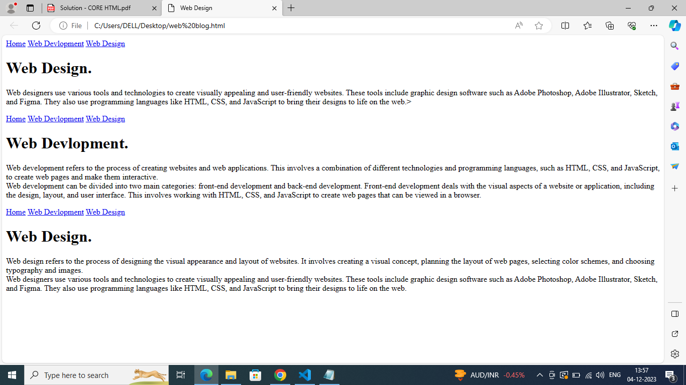

Q4)

Ans :-

<!DOCTYPE html>
<html lang="en">
<head>
<meta charset="UTF-8">
<meta name="viewport" content="width=device-width, initial-scale=1.0">
<title>Ordered list with HTML tags</title>
</head>
<body>
<h1>List of tags.</h1>
<ol>
<li>h1:It defines top most heading.</li>
<li>p:This issome text.</li>
<li>br:It defines a line breaks.</li>
<li>span:It functions as an inline container allowing
us to markup and highlight specific portions of text
within a document.
</li>
<li>hr:It defines a thematic break.</li>
<li>div:Defines a container for HTML elements.</li>
<li>table:Defines a table with row and columns.</li>
<li>ul:Defines an unordered list.</li>
</ol>
</body>
</html>

OUTPUT :-

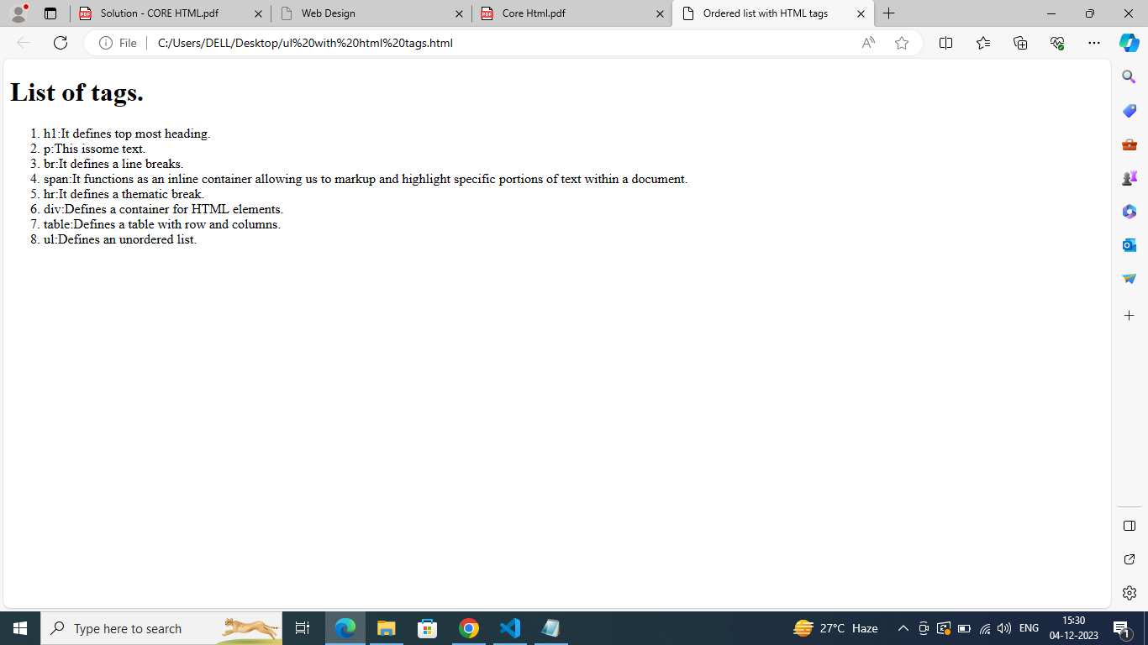

Q5)

Ans :-

<!DOCTYPE html>
<html lang="en">
<head>
<meta charset="UTF-8">
<meta name="viewport" content="width=device-width, initial-scale=1.0">
<title>Description List</title>
</head>
<body>
<h1>Full Stack Web Development Tech Stack</h1>
<dl>
<dt>HTML</dt>

<dd>HyperText Markup Language is the standard markup language for creating

web pages and other online documents.</dd>

<dt>CSS</dt>

<dd> Cascading Style Sheets is a style sheet language used for describing the

presentation of a document written in HTML or XML.</dd>

<dt>JavaScript</dt>

<dd> JavaScript is a programming language used to create interactive effects

within web browsers.</dd>

<dt>Node.js</dt>

<dd> Node.js is an open-source, cross-platform, JavaScript runtime

environment that executes JavaScript code outside of a browser.></dd>

<dt>Express.Js</dt>
<dd> Express.js is a web application framework for Node.js designed for

building web applications and APIs.</dd>

<dt>MongoDB</dt>
<dd> MongoDB is a NoSQL document-oriented database program that uses

JSON-like documents with optional schemas.</dd>

<dt>React.js</dt>
<dd> React.js is a JavaScript library for building user interfaces or UI

components.</dd>

</dl>
</body>
</html>

OUTPUT :-

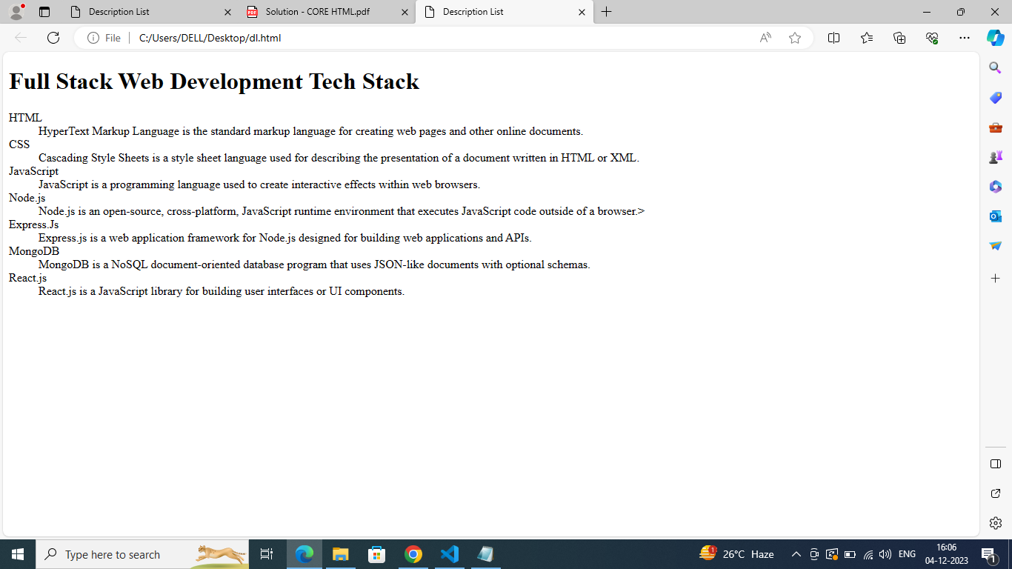

Q6)

Ans :-

<!DOCTYPE html>
<html lang="en">
<head>
<meta charset="UTF-8">
<meta name="viewport" content="width=device-width, initial-scale=1.0">
<title>Ordered List with Stacks</title>
</head>
<body>
<ol>
<li>
<h2>HTML</h2>
<table border="1">
<tr>
<th>Primary Use Cases</th>
<th>Key Features/Benefits</th>
</tr>
<tr>
<td>Building the structure of the web page</td>
<td>
<ul>
<li>Simple and easy to learn</li>
<li>Compatible with all web browsers</li>
<li>Allows for semantic markup</li>
</ul>
</td>
</tr>
</table>
</li>
<li>
<h2>CSS</h2>
<table border="1">
<tr>
<th>Primary Use Cases</th>
<th>Key Features/Benefits</th>
</tr>
<tr>
<td>Styling and layout of web pages </td>
<td>
<ul>
<li>Allows for separation of content and presentation</li>
<li>Enables responsive design</li>
<li>Offers a wide range of styling options</li>
</ul>
</td>
</tr>

</table>
</li>
<li>
<h2>JavaScript</h2>
<table border="1">
<tr>
<th>Primary Use Cases</th>
<th>Key Features/Benefits</th>
</tr>
<tr>
<td>Adding interactivity and functionality to web pages</td>
<td>
<ul>
<li>Can manipulate and modify web page content in real-time</li>
<li> Offers a wide range of functionality through libraries and

frameworks</li>
<li>Allows for server-side scripting with Node.js</li>
</ul>
</td>
</tr>
</table>
</li>
</ol>
</body>
</html>

OUTPUT :-

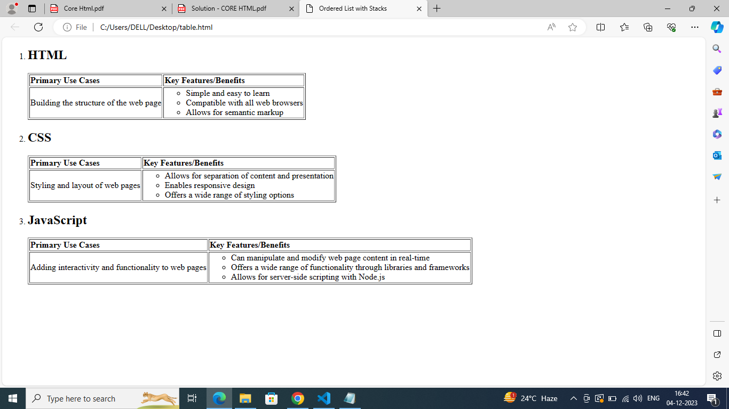

Q7)

Ans :-

<!DOCTYPE html>
<html lang="en">
<head>
<meta charset="UTF-8">
<meta name="viewport" content="width=device-width, initial-scale=1.0">
<title>Complex Nested List </title>
</head>
<body>
<h1>Table of Content</h1>
<ul>
<li><a href="#">Part 1: Introduction</a></li>
<li><a href="#">Part 2: Getting Started</a>
<ul>
<li><a href="#">Part 2.1: Installing the Software</a></li>
<li><a href="#">Part 2.2: Creating a New Project</a>
<ul>
<li><a href="#">Part 2.2.1: Project Templates</a></li>
<li><a href="#">Part 2.2.2: Customizing Settings</a></li>
</ul>
</li>
<li><a href="#">Part 2.3: Exploring the Interface</a>
<ul>
<li><a href="#">Part 2.3.1 Toolbar Feaatures </a></li>
<li><a href="#">Part 2.3.2 Panel Layout</a>
<ul>
<li><a href="#">Part 2.3.2.1 Docking Panel </a></li>
<li><a href="#">Part 2.2.2.2 Tabbed Interface</a></li>
</ul>
</li>
</ul>
</li>
</ul>
</li>
<li><a href="#">Part 3: Advance Topic</a>
<ul>
<li><a href="#">Part 3.1: Working with Plugins</a>
<ul>
<li><a href="#">Part 3.1.1: Installing Plugins</a></li>
<li><a href="#">Part 3.1.2: Plugin Configuration</a></li>
</ul>
</li>
<li><a href="#">Part 3.2: Customizing the UI</a>
<ul>
<li><a href="#">Part 3.2.1 Changing Themes</a></li>
<li><a href="#">Part 3.2.2 Configuring Shortcuts</a></li>
</ul>
</li>
<li><a href="#">Part 3.3 Optimizing Performance</a>
<ul>
<li><a href="#">Part 3.3.1 Caching Strategies</a></li>
<li><a href="#">Part 3.3.2 Resource Minification</a></li>
</ul>
</li>
</ul>
</li>
<li><a href="#">Part 4 Conclusion</a></li>
</ul>
</body>
</html>

OUTPUT :-
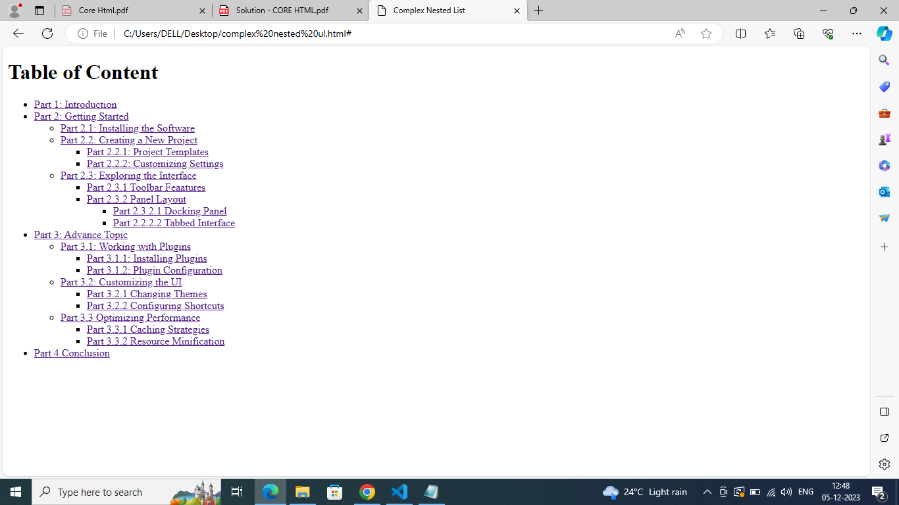

Q8)

Ans :-
<!DOCTYPE html>
<html lang="en">
<head>
<meta charset="UTF-8">
<meta name="viewport" content="width=device-width, initial-scale=1.0">
<title>Time table</title>
</head>
<body>
<h1>Conference Schedule</h1>
<table border="1" cellpading="10">
<thead>
<tr>
<th>Time</th>
<th>Room 1</th>
<th>Room 2</th>
<th>Room 3</th>
<th>Room 4</th>
</tr>
</thead>
<tbody>
<tr>
<td rowspan="3">9:00 AM - 10:00 AM</td>
<td rowspan="2">Keynote</td>
<td>Session A</td>
<td>Session B</td>
<td rowspan="3">Session C</td>
</tr>
<tr>
<td>Session D</td>
<td>Session E</td>
</tr>
<tr>
<td>10:30 PM - 11:30 PM</td>
<td colspan="2">Session F</td>
</tr>
<tr>
<td>12:00 PM - 1:00 PM</td>
<td colspan="4">Lunch Break</td>
</tr>
<tr>
<td rowspan="2">1:00 PM - 2:00 PM</td>
<td>Session G</td>
<td rowspan="2">Session H</td>
<td>Session I</td>
<td>Session J</td>
</tr>
<tr>
<td>Session K</td>
<td>Session L</td>
<td>Session M</td>
</tr>
</tbody>
</table>
</body>
</html>

OUTPUT : -
